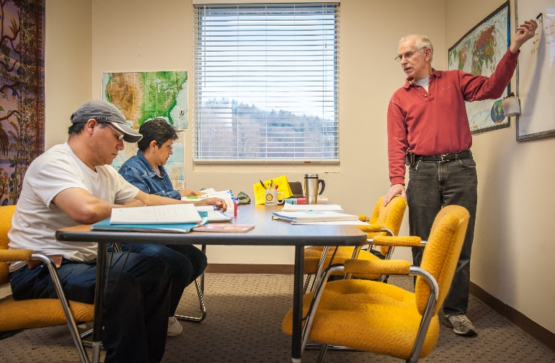
Volunteer Orientation Dates
July-December 2017
Choose one orientation session:

- August 22, 5:30 pm – 7:00 pm
- August 24, 9:00 am – 10:30 am
- September 26, 5:30 pm – 7:00 pm
- September 28, 9:00 am – 10:30 am
- October 19, 5:30 pm – 7:00 pm
- October 26, 9:00 am – 10:30 am
- November 14, 5:30 pm – 7:00 pm
- November 16, 9:00 am – 10:30 am

Adult Education
Volunteer Tutor Training
Choose one 4-week training series:

- Tues., August 15, 5:30 pm – 8:00 pm
- Tues., August 22, 5:30 pm – 8:00 pm
- Tues., August 29, 5:30 pm – 8:00 pm
- Tues., September 5, 5:30 pm – 8:00 pm
- Reunion: Nov. 7, 5:30 pm – 8:00 pm
- Tues., October 3, 5:30 pm – 8:00 pm
- Tues., October 10, 5:30 pm – 8:00 pm
- Tues., October 17, 5:30 pm – 8:00 pm
- Tues., October 24, 5:30 pm – 8:00 pm
- Reunion: Dec. 5, 5:30 pm – 8:00 pm
- Tues., November 28, 5:30 pm – 8:00 pm
- Tues., December 5, 5:30 pm – 8:00 pm
- Tues., December 12, 5:30 pm – 8:00 pm
- Tues., December 19, 5:30 pm – 8:00 pm
- Reunion: Jan. 23, 5:30 pm – 8:00 pm
- Tues., February 6, 5:30 pm – 8:00 pm
- Tues., February 13, 5:30 pm – 8:00 pm
- Tues., February 20, 5:30 pm – 8:00 pm
- Tues., February 27, 5:30 pm – 8:00 pm
- Reunion: April 10, 5:30 pm – 8:00 pm
English for Speakers of Other Languages
Volunteer Tutor Training
Choose one 4-week training series:

- Thurs., July 6, 5:30 pm – 8:00 pm
- Thurs., July 13, 5:30 pm – 8:00 pm
- Thurs., July 20, 5:30 pm – 8:00 pm
- Thurs., July 27, 5:30 pm – 8:00 pm
- Reunion: October 26, 5:30 pm – 8:00 pm
- Thurs., September 7, 5:30 pm – 8:00 pm
- Thurs., September 14, 5:30 pm – 8:00 pm
- Thurs., September 21, 5:30 pm – 8:00 pm
- Thurs., September 28, 5:30 pm – 8:00 pm
- Reunion: January 4, 5:30 pm – 8:00 pm
- Thurs., November 2, 5:30 pm – 8:00 pm
- Thurs., November 16, 5:30 pm – 8:00 pm
- Thurs., November 30, 5:30 pm – 8:00 pm
- Thurs., December 7, 5:30 pm – 8:00 pm
- Reunion: April 12, 5:30 pm – 8:00 pm
- Thurs., January 11, 5:30 pm – 8:00 pm
- Thurs., January 18, 5:30 pm – 8:00 pm
- Thurs., January 25, 5:30 pm – 8:00 pm
- Thurs., February 1, 5:30 pm – 8:00 pm
- Reunion: April 26, 5:30 pm – 8:00 pm

